

Semester One Examination 2019

Question/Answer Booklet

PHYSICS
UNIT 1

Answer Key

Time allowed for this paper:
Reading time before commencing work: 10 minutes
Working time for paper: 3 hours

Materials required/recommended for this paper
To be provides by the supervisor
This Question/Answer Booklet
Formulae and Data Booklet

To be provided by the candidate
Standard items: pens, pencils (including coloured), sharpener, correction fluid, eraser, ruler, highlighters.
Special items: up to three non-programmable calculators approved for use in the WACE examinations, drawing templates, drawing compass and a protractor.

STRUCTURE OF THIS PAPER

Section | No. of  Questions | No. of questions  to be attempted | Suggested working time  (minutes) |  | Marks available | Percentage of  exam
Section one  Short Response | 11 | ALL | 55 |  | 54 | 30
Section two  Problem Solving | 6 | ALL | 95 |  | 90 | 50
Section three  Comprehension | 2 | ALL | 30 |  | 36 | 20
 |  |  |  | Total | 180 | 100

INSTRUCTIONS TO CANDIDATES

Write your answers in the spaces provided beneath each question. The value of each question (out of 180) is shown following each question.

Answers to questions involving calculations should be evaluated and given in decimal form. Final answers should be given up to three significant figures and include appropriate units.

Questions containing the instruction "estimate" may give insufficient numerical data for their solution. Give final answers to a maximum of two significant figures and include appropriate units.

Despite an incorrect final result, credit may be obtained for method and working providing these are clearly and legibly set out.

Questions containing specific instructions to show working should be answered with a complete, logical, clear sequence of reasoning showing how the final answer was arrived at; correct answers which do not show working will not be awarded full marks.

Section One: Short Response 30% (54 marks)

This section has 11 questions. Answer all questions. Answer the questions in the spaces provided.
Suggested working time: 50 minutes.

Question 1 (3 marks)

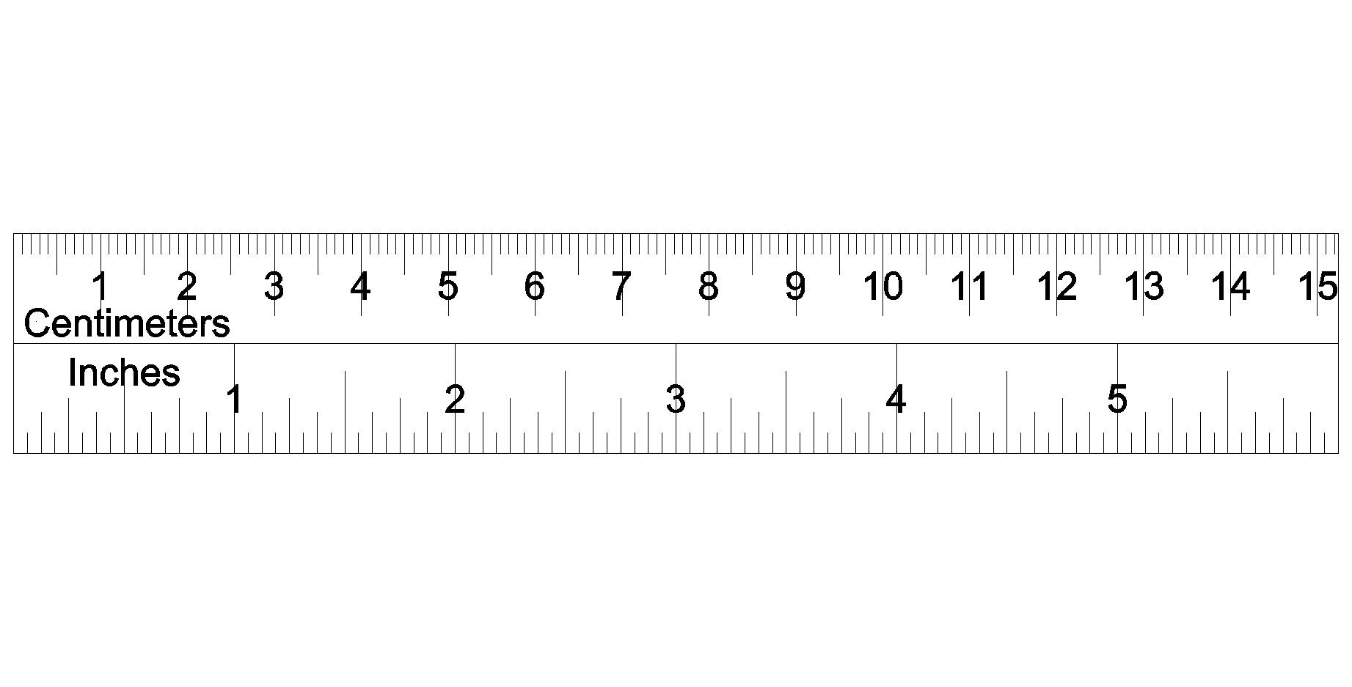
Aiden is measuring the following shaded perfect circle and he puts a ruler next to it, as shown on the right.

Write the absolute and relative uncertainties of the diameter of the circle below.

- Diameter with absolute uncertainty :

2.70 cm ± 0.05 cm (or 0.1 cm)

- Diameter with relative uncertainty:

2.70 cm ± 1.9 % (or 3.7%)

Space for working out:

$\frac{0.05}{2.7}×100=1.85\%$

Note: Teachers are welcome to remove the rule from the diagram.

Question 2 (3 marks)
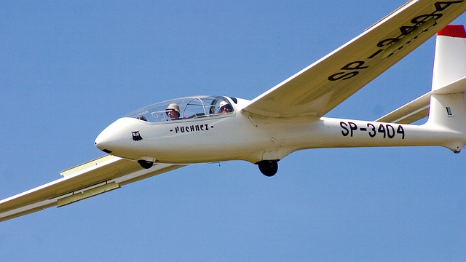
A glider, as shown on the right, is a light aircraft that is designed to fly without using an engine over a large plain field. As the field is heated by the sun, it is able to operate more effectively. Explain the reasons using Physics concepts.

- The hot ground radiates heat and warms the air above it.
- This causes the reduction of air density.
Warm air then rises (convection current).
- This provides an additional upward force to the glider so that it
remains in the air.

Question 3 (5 marks)

Sodium-24 has a half-life of 15.0 hours. It has applications in medicine and engineering.

- How much of a 34.0 g sample of Sodium-24 will remain undecayed after two days? Show clear working. (3 marks)

- Time is in hours:
$t=2×24=48 \text{hours}$

- Decay calculation
$N=N_{o}{\left(\frac{1}{2}\right)}^{\frac{t}{t_{\frac{1}{2}}}}$ $=34×{\left(\frac{1}{2}\right)}^{\frac{48}{15}}$ $=3.6998 \text{g}$
- Answer = 3.70 g

- If Iodine-131 (half-life = 8.00 days) of the same amount were to replace Sodium-24, would more of the original sample be left over or less compared to Sodium-24? Explain without calculations. (2 marks)

- More.
- The half-life of iodine-131 is longer, that means it
decays slower than sodium-24.

Question 4 (4 marks)

A hot body is brought into contact with a colder body until their temperatures are the same. Assume that no other bodies are nearby.

(a) Is the energy lost by one body equal to the energy gained by the other? Explain your answer.
(2 marks)
Yes. ✔The thermal energy lost by one body must equal the thermal energy gained by the other because of energy conservation. ✔

(b) Is the temperature drop of one body is equal to the temperature rise of the other? Explain your answer.
(2 marks)
Yes or No. ✔The changes in temperature are not, however, necessarily equal because the masses and specific heat capacities may differ. ✔

Question 5 (7 marks)

A food shop sells hot beef soup. A number of slices of beef are put into a bowl, followed by pouring in a hot liquid vegetable stock. The soup is then ready to serve to customers.

Use the following information to answer the questions:
- Mass of vegetable stock: 0.800 kg
- Initial temperature of the stock: 96.0 ºC
- Specific heat capacity of the stock: 4000 J kg⁻¹ K⁻¹
- Mass of each beef slice: 50.0 g
- Initial temperature of beef: 6.00 ºC
- Specific heat capacity of beef: 3000 J kg⁻¹ K⁻¹

- According to safety regulations, the serving temperature of the soup should be below 60.0 ºC. Estimate the minimum number of beef slices required to add to the stock to achieve this.
(6 marks)

- Setup for heat loss:
$$∆Q_{\text{loss}}=m∙c∙∆T \\ =0.8×4000×\left(96-60\right) \\ =115200 \text{J}$$

- Setup for one slice of beef (heat gain):
$$∆Q_{\text{gain}}=m∙c∙∆T \\ =0.05×3000×\left(60-6\right) \\ =8100 \text{J}$$

- Q_{gain} = Q_{loss}

- Calculation of number of slices of beef:
$$\text{no. of slices}=\frac{115200}{8100} \\ =14.2$$

- Answer: at least 15 slices.

- State one assumption in the calculation in part a). (1 mark)

- Assuming no energy is lost to the environment.

Question 6 (7 marks)

The diagram below shows a neutron, n, being absorbed by a Uranium-235 atom. The remaining neutrons then continue to react with other Uranium-235 atoms.
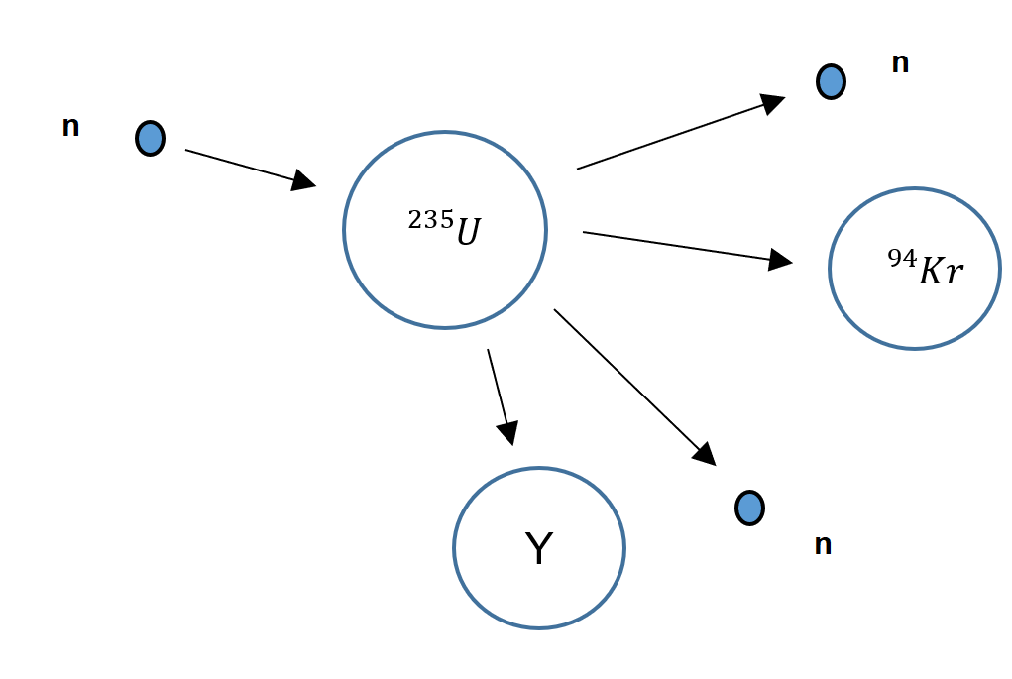
- Complete the following table by writing the correct terminologies: (3 marks)

Descriptions | Terminologies
A neutron collides with a Uranium nucleus and is absorbed. | Neutron capture
The atom splits into different two atoms and two neutrons. | Fission
The released neutrons continue to be absorbed by other Uranium-235 nuclei. | Chain reaction

- Predict what substance Y be. Write the symbol of the substance, its atomic number and mass number in a correct format. (2 marks)

${}_{56}^{140}{\text{Ba}}$

- If the Krypton-94 continues to decay and release a beta negative particle. Write the full nuclear equation for this decay. (2 marks)

${}_{36}^{94}{\text{Kr}→ {}_{-1}^{0}{β+{}_{37}^{94}{\text{Rb+}\overline{ν}}}}$

Question 7 (5 marks)

The diagram below is a simple schematic diagram of a fridge. It consists of one long coil that goes through the inside compartment of the fridge and then flows outside. Fluid refrigerant is sealed inside this coil. The arrow, in the diagram below, shows the direction of the refrigerant. Part C is called an expansion valve. The pressure inside the pipe is reduced by the expansion valve, causing the refrigerant to evaporate.
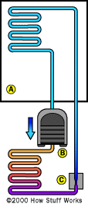
- Explain how this helps to cool the fridge. (3 marks)

- As the refrigerant evaporates, turning from liquid to gas.
It then absorbs energy from the surrounding.
- This allows the heat to be removed from the air so
it becomes cooler.

- When there is a power outage, a fridge can still keep the contents cold for as long as 2 hours. Describe the features of a fridge which help to keep the fridge cold. (2 marks)

- A fridge is made of insulators.
- Sealed shut to prevent heat coming from outside.
- Hollow doors to prevent conduction while silver to reflect OR radiation.

(any two features relate to conduction, convection and radiation)

Question 8 (6 marks)

When we discuss radiation doses, there are essentially two different types of “doses”; absorbed dose and dose equivalent.

(a) Explain the difference between absorbed dose and dose equivalent? (2 marks)
Absorbed dose is used to assess the potential for biochemical changes in specific tissues. ✔
Equivalent dose is used to assess how much biological damage is expected from the absorbed dose. (Different types of radiation have different damaging properties.) ✔

The table below shows the dose equivalent for several common medical scans.
Procedure | Approximate dose equivalent (mSv) | Comparable to natural background radiation for
CT – Abdomen and pelvis | 10 | 3 years
CT – Abdomen and pelvis, repeated with and without contrast | 20 | 7 years
CT – Colonoscopy | 6 | 2 years
Intravenous Pyelogram | 3 | 1 year
Barium enema (Lower GI X ray`` | 8 | 3 years
Upper GI study with Barium | 6 | 2 years

(b) Suppose a 50.0 kg person is having a CT-colonoscopy, with the radioisotope used being
a slow neutron emitter. Determine the absorbed radiation dose AND the total energy absorbed?
(3 marks)
(c) Background radiation includes radiation comes from environmental sources including the earth's
DE = AD x QF
thus 6.0 x 10⁻³ = AD x 3✔
thus AD = 2.0 x 10⁻³ Jkg⁻¹ ✔
and total energy absorbed = 50 x 2.0 x 10⁻³ = 1.0 x 10⁻¹ J✔
is the unit that takes into account the absorbed dose (energy per unit mass) ✔ to all organs of the body, the relative harm level of the radiation✔, and the sensitivities of each organ to radiation✔.

crust, the atmosphere, cosmic rays, and radioisotopes. CT – Abdomen and pelvis, repeated with and without contrast has such a high background radiation equivalence. Suggest a type of radiation that could produce such a high equivalence (1 mark)
Alpha particles or fast neutrons as they have a high quality factor✔

Question 9 (5 marks)

The graph below shows the decay of radiative substance Z.

- Use the graph above to estimate the half-life of substance Z. Show your working on the graph above. (2 marks)

- Approximately 1.7 minutes. (± 0.1 min)
- Show working out on the graph.

- Hence, estimate how long it would take for substance Z to decrease to 10.0 Bq of activity. (3 marks)

Option 1 Using systematic method

- Setup

450 225 112.5 56.25 28.125 14.0625 7.03125

- Number of half-lives
Total 6 half-lives

- Calculation of total time
t = 6 x 1.7 = 10.2 minutes

- Answer: t = 10 minutes

Option 2 Using calculation

- Setup
$$N=N_{o}{\left(\frac{1}{2}\right)}^{\frac{t}{t_{\frac{1}{2}}}}$$$10=450∙{\left(\frac{1}{2}\right)}^{\frac{t}{1.7}}$

- Solving
$$0.02222={\left(\frac{1}{2}\right)}^{\frac{t}{1.7}} \\ \log{0.02222=\frac{t}{1.7}\log{\frac{1}{2}}} \\ -1.6532=\frac{t}{1.7}\left(-0.30103\right) \\ t=9.336$$

- Answer: t = 9.3 minutes

Question 10 (5 marks)

Find the binding energy, per nucleon in, MeV, for Uranium-236.

Use the following data:

Mass of proton = 1.00727 u
Mass of neutron = 1.00867 u
Mass of Uranium-236 = 236.045568 u

- Number of protons and neutrons:
p = 92 n = 144

- Mass of total nucleons:
$$m=92×1.00727u+144×1.00867u \\ =237.91732u$$

- Difference of mass:
$$∆m=237.91732u-236.045568u \\ =1.871752u$$

- Converting energy to MeV
$$E=1.871752×931 \\ =1742.60 \text{MeV}$$

- Energy per nucleon
$$E=1742.60 \text{÷236} \\ =7.3839 \text{MeV per nucleon}$$
- Answer = 7.38 MeV per nucleon.

Question 11 (4 marks)
Calculate how much energy needs to be removed to convert 500 g of water from 24.0 ºC into ice at –4.00 ºC ice.

- Heat removed between 0 and 24 ºC
$$ΔQ=m∙c∙ΔT \\ =0.5×4180×24 \\ =50160 \text{J}$$

- Heat removed in latent heat
$$ΔQ=m∙L \\ =0.5×3.34×{10}^{5} \\ =167000 \text{J}$$

- Heat removed between – 4 and 0 ºC
$$ΔQ=m∙c∙T \\ =0.5×2100×4 \\ =4200 \text{J}$$

- Total heat to be removed
$$Q=50160+167000+4200 \\ =221360 \text{J}$$

- Answer Q = 2.21 x 10⁵J
END OF SECTION ONE
Section Two: Problem-solving 50% (90 marks)

This section contains 6 questions. Answer all questions. Answer the questions in the spaces provided.
Suggested working time 90 minutes.

Question 12 (16 marks)


John carries out an experiment to investigate the cooling properties of
Octadecan-1-ol. Octadecan-1-ol is one type of alcohol that can be used in anti-freeze products and lubricants. Its latent heat of fusion is 331 J kg⁻¹.

John heats a test tube containing of 250 g solid Octadecan-1-ol in a water bath at 80.0 ºC. He then puts the test tube immediately into a beaker of iced water.

The temperature of the Octadecan-1-ol is then recorded over a time interval of 5.00 minutes. The results are shown below:

Time (s) | 0 | 30 | 60 | 90 | 120 | 150 | 180 | 210 | 240 | 270 | 300
Temperature (ºC) | 71 | 63 | 57 | 55 | 55 | 55 | 55 | 55 | 50 | 44 | 35

- Plot a cooling curve of Octadecan-1-ol in the graph below. A spare graph paper can be found on page 31.
(2 marks)

- Accuracy of data
- Axes with units

- Estimate the melting point of Octadecan-1-ol, in Kelvin. (2 marks)
- 55 ºC
- Answer = 330 K (2sf)
- Use kinetic particle theory to explain the shape of the curve between 90 seconds and 210 seconds.
(3 marks)
- Particles get closer together.
i.e. it loses energy.
- Therefore, potential energy is decreased.
- Kinetic energy remains constant.

- Use the given information to calculate the rate of heat loss of the 250 g of Octadencan-1-ol in between 90 seconds and 210 seconds. (4 marks)

- Time t = 120 s

- Heat absorbed
$$Q=331×0.25 \\ =82.75 \text{J}$$

- Power calculation
$$P=\frac{82.75}{120} \\ =0.68958 \text{W}$$

- Answer = 0.690 W

- If the experiment was to be done in thermally insulated conditions, would your answer for part d) be higher or lower? Explain your answer. (3 marks)

- Lower.
- Under insulated condition, the time taken to lose.
heat will be longer as no energy is lost in the environment.
- $P∝\frac{1}{t}$

- List one possible example of random error and one possible example of systematic error in this experiment. (2 marks)

Random error: uncertain amount of heat lost to the environment.

Systematic error: thermometer reading may not be calibrated properly.
(or any valid answers)
Question 13 (13 marks)

In a juice factory, a radioactive source and a Geiger-Muller (GM) counter are used to ensure each box of juice is full before delivering to the shops. The radiation emitted by the source penetrate through the top section part of each box and are then detected by the GM counter as shown in the following diagram.

Radioactive source

Juice

Juice

Juice

Lead Shield

GM counter

The following table shows a sample of results recorded by the GM counter:

Box Number | 1 | 2 | 3 | 4 | 5
Measured count rate (Bq) | 645 | 652 | 648 | 729 | 654

- What type of radiation (alpha, beta or gamma) should be used for the radioactive source? Explain. (2 marks)

- Beta particle (either positive or negative).
- Moderate penetration ability allows the particles to be
stopped according to the amount of juice.

- Why was there an increase in the measured count rate when the fourth box of juice passes through the detector? Explain your reason. (2 marks)

- The volume of the juice in the box must have been less
than others.
- This causes more particles to reach the GM counter.

- It is claimed that as long as the radiation penetrate through the top part of the juice box and are detected by the GM counter, the distance between the source and the detector is NOT critical. Comment on this statement. (2 marks)

- Radiation’s activity is inversely proportional to distance.
- As such, distance can affect the detection of radiation.

- If you were the manager of the factory and had a choice of half-lives of the radioactive source shown below. Which one would you choose? Circle your answer. (1 mark)

10 seconds 10 hours 10 years

- Briefly explain your answer of your above choice. (1 mark)

- This is because the radioactive source does not
required replacement more often.

- Comment on the purpose of the lead shield. (1 mark)

- To protect the factory employees from harmful radiation.

- All factory workers who work in this juice factory must wear radiation monitoring badges. These badges monitor the radiation exposure to a factor worker. A person whose mass is 75.0 kg receives an average of 3.00 J a day according to the badge. Estimate the dose equivalent this person receives every day. Use your answer in part a) for the calculation. (4 marks)

- Calculation of Absorb Dose:
$$AD=\frac{E}{m} \\ =\frac{3}{75} \\ =0.040 \text{Gy}$$
- Calculation of Dose Equivalent:
$$DE=AD×QF \\ =0.04×1 \\ =0.040 \text{Sv}$$

- Answer: 0.040 Sv unit also correct, 2sf.

Question 14 (18 marks)

The isotope tritium (hydrogen-3) has a radioactive half-life of 12 days.
(a) State what is meant by the term “isotope”. (2 marks)
Nuclides or atoms or elements that have same number of protons✔
(same element) but different nucleon (neutron) numbers✔

(b) Define radioactive half-life. (1 mark)
Tritium may be produced by bombarding a nucleus of the isotope lithium-7 with a high-energy neutron. The reaction equation for this interaction is:
$${}_{3}^{7}{Li+ {}_{0}^{1}{n→{}_{1}^{3}H}}+ {}_{Z}^{4}{X+ }{}_{0}^{1}n$$ (c) Identify the atomic number, Z, of X. (1 mark)
2 ✔

The time taken for the activity (of a radioactive sample) to decrease by half✔

(d) Use the following data to show that the minimum energy that a neutron must have to initiate the reaction in (c) is about 2.5MeV.
(3 marks)
Rest mass of lithium-7 nucleus =7.0160 u
Rest mass of tritium nucleus =3.0161 u
Rest mass of X nucleus =4.0026 u
(e) A nucleus of tritium decays to a nucleus of helium-3. Identify the particle X in the nuclear
mass difference = 7.0160 – (3.0161 + 4.0026 ) = (-) 2.7x 10³ u ✔
energy required = (-) 2.7x 10³ x 931.5
= 2.5 MeV✔✔
reaction equation for this decay shown below.
${}_{1}^{3}{H→{}_{2}^{3}{H+}} X+ {}_{0}^{0}ν$ (1 mark)
X is a beta particle or an electron ✔ 

A sample of tritium has an activity of 8.0×10⁴ Bq at time t=0 and the half-life of tritium is 12 days.
(f) Using the axes below, construct a graph to show how the activity of the sample varies with time from t = 0 to t = 84 days.
(5 marks)
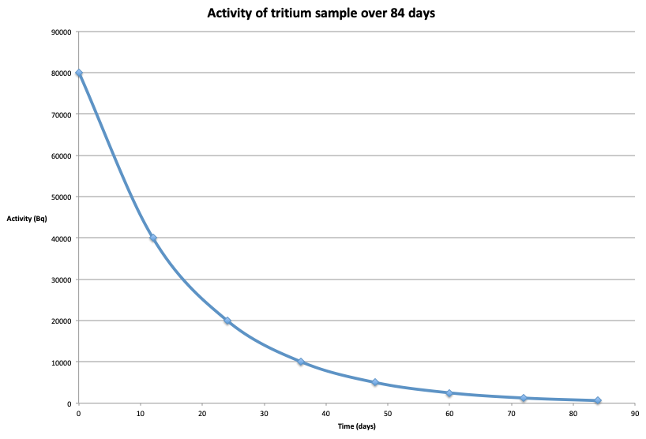
Five correct data points ✔✔
Smooth curve✔
Labels on each axis✔
Units on each axis✔

(g) Use the graph to determine the activity of the sample after 30 days.
(2 marks)
From graph 1.4 x 10⁴ Bq ✔✔
(h) The activity of a radioactive sample is proportional to the number of atoms in
the sample. The sample of tritium initially consists of 1.2×10¹¹ tritium atoms.
Determine, using your answer to (g) the number of tritium atoms remaining
after 30 days.
(3 marks)
number of atoms left = (1.2 x 10¹¹) x (1.4 x10⁴/8 x 10⁴)
= 2.1 x 10¹⁰ atoms ✔✔✔

Question 15 (13 marks)


On average, a person, through perspiration, loses up to 400 mL of water every hour even sitting in an comfortable office. The latent heat of vaporisation of water at a comfortable temperature is 2.42 x 10⁶ J kg⁻¹. Note: density of water is 1.00 kg L⁻¹

- Explain how water assists heat loss for human bodies to prevent hyperthermia, a scientific term to describe a body temperature above 40.0 ºC. (3 marks)

- When water is evaporated it requires energy to do so.
- The energy can be accessed from the human body.
- Removal of energy from the body helps lower the
temperature.

- Jane, whose mass is 55.0 kg, has been at work for 8.00 hours.

- How much heat energy does Jane’s body lose at work, through the evaporation of water? Assume the evaporating perspiration does not absorb heat from anywhere else. (3 marks)

- Mass of water over 8 hours:
$$m=0.4×8 \\ =3.2 \text{kg}$$

- Setup:
$$∆Q=m∙L \\ =0.4×2.42×{10}^{6} \\ =7744000 \text{J}$$

- Answer Q = 7.74 x 10⁶ J

- By how much would Jane’s body temperature rise if the same amount of water in part i) did not evaporate from her skin? Assume the specific heat capacity of a human body is 3500 J kg⁻¹ K⁻¹. (2 marks)
- Using specific heat calculation:
$$∆Q=m∙c∙∆T \\ 7744000=55×3500×∆T \\ ∆T=40.229$$

- Answer : change of temperature = 40.2 ºC

- Jane finds that using a fan which blows air across her skin helps her feel more comfortable while working in a hot office. Explain why. (3 marks)

- The fan remove the water vapour around the skin.
This reduces the saturation of the water vapour.
- As a result, it encourages more water on the skin to
evaporate which in turn removes more heat from Jane’s
body.

- After work, Jane goes to a swimming pool. Explain why she often feels colder when she gets out of the water, even if the temperature of the air and the water are the same. (2 marks)

- Greater the mass of water, greater the evaporation
rate. As a result, more heat is removed during
this process.
- This process will reduce the skin temperature.

Question 16 (14 marks)

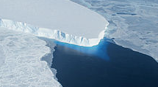
The Pobeda ice island in Antarctica is created and vanishes periodically. It is created by the calving of an enormous block of ice from Denman Glacier. The resulting iceberg drifts until it runs aground upon a shoal north of the ice shelf. The iceberg is remains locked in this position for a decade or more, until it has remodelled enough to free itself from the shoal. It then drifts into the open ocean, where it breaks into fragments. These iceberg fragments eventually melt as they drift into warmer waters.

Use the following additional data to answer the questions that follow.
Typical dimensions of surface of the island = 70 km×35 km
Typical height of island = 240m
Average temperature of the island = –35 C°
Mass of 1.0 m³ of sea ice = 920 kg

(a) Distinguish, with reference to molecular motion and energy, between solid ice and liquid water.
(4 marks)
In water, molecules are able to move relative to other molecules, less movement possible in ice ✔
in water, vibration and bulk movement of molecules possible, in ice only vibration; ✔
in liquid there is sufficient energy/vibration (from latent heat) to break and re-form inter-molecular bonds✔✔

(b) Given the dimensions of the island and the data above, show that the mass of Pobeda island is about 5.4 x 10¹⁴ kg?
(2 marks)
Volume of island = (70 x 10³) x (35 x10³) x (240)
=5.88 x 10¹¹ m³ ✔

One m³ has a mass of 920 kg, thus the mass of the island is 5.88 x 10¹¹ x 920, which is about 5.4 x 10¹⁴ kg ✔

(c) Show that the energy required to melt the island to form water at 0 C° is about 2.0 ×10²⁰ J. Assume that the top and bottom surfaces of the island are flat and that it has vertical sides.
(3 marks)
(d) The Sun supplies thermal energy at an average rate of 450Wm^{–2} to the surface of the island. Estimate the time taken to the nearest year to melt the island and list any assumptions that you make.
(5 marks)
Q₁ = thermal energy to raise ice at -35ºC to ice at OºC
= mcΔt
=5.4 x 10¹⁴ x 2.1×10³ x (35)
= 3.97 x10¹⁹✔
Q₂ = thermal energy to melt ice without change in temperature.
= mL
= 5.4 x 10¹⁴ x 3.3×10⁵
= 1.78 x 10²⁰ ✔
Energy required = Q₁ +Q₂ = 2.2 x 10²⁰ J✔

assuming that the melted water is removed immediately ✔and that no heat is lost to the surroundings✔

Surface area of island = (70 x 10³) x (35 x10³) = 2.45 x 10⁹ m²✔

Total energy supplied by the sun per second = 2.45 x 10⁹ x 450
= 1.10 x 10¹² J✔
Time required = 2.2 x 10²⁰/1.10 x 10¹²
= 2.0 x 10⁸ seconds
= 6.3 year✔  (ie 6 Years)
Question 17 (16 marks)

The Sun constantly undergoes a series of fusion reactions to produce a large amount of energy. A common series of reactions that occurs within the sun is outlined in the steps below.

- Two protons fuse together, producing Deuterium and other particles plus energy;
- Deuterium and a proton fuse, producing Helium-3 and energy;
- Two Helium-3 nuclei fuse together, producing Helium-4, two protons, and energy;
- Helium-3 fuses with Helium-4, producing Beryllium-7, which decays and then fuses with another proton to yield two Helium-4 nuclei plus energy.

Use the following data to answer the questions below:

Element | Scientific name | Mass (u)
${}_{1}^{1}H$ or ${}_{1}^{1}p$ | Protium/Proton | 1.008
$${}_{1}^{2}H$$ | Deuterium | 2.015
$${}_{1}^{3}H$$ | Tritium | 3.015
$${}_{2}^{3}He$$ | Helium-3 (Helion) | 3.016
$${}_{2}^{4}{He}$$ | Helium-4 | 4.003
$${}_{0}^{1}n$$ | Neutron | 1.008

- For step 3, write the full nuclear equation for the process. (2 marks)

${}_{2}^{3}{He}+{}_{2}^{3}{He}→ {}_{2}^{4}{He+}2{}_{1}^{1}p$

- Use the information above to calculate the energy released, in MeV, for step 3 (part i)). Correct the answer to two significant figures. (5 marks)

- Mass of reactants
$$m_{R}=3.016u×2 \\ =6.032u$$

- Mass of products
$$m_{P}=4.003u+1.008u×2 \\ =6.019u$$

- Mass defect
$$∆m=6.032u-6.019u \\ =0.013u$$

- Energy equivalent
$$E=0.13×931 \\ =12.103 \text{MeV}$$

- Answer E = 12 MeV

- Calculate the total energy, in Joules, that would be produced from 50.0 Tonnes of Helium-3 undergoing the reaction in Step 3. Correct your answer to two significant figures. (5 marks)

- Number of Helium atoms
$$n=\frac{50000}{3.016×1.66×{10}^{-27}} \\ =9.9869×{10}^{30}$$

- Total energy released
$$E=9.9869×{10}^{30}×12.103 \text{MeV} \\ =1.2087×{10}^{32}\text{MeV}$$
- Energy conversion into Joules
$$E=1.2087×{10}^{38}\text{×1.6×}{10}^{-19} \\ =1.9339×{10}^{19}\text{ J}$$

- Answer E = 1.9 x 10¹⁹ J

- Helium-4 is more stable than Tritium. Comment on this statement. (2 marks)

- A Helium-4 atom has 2 protons and 2 neutrons
whereas a tritium atom has 1 proton and 2 neutron.
- The Helium-4 has even ratio of protons and neutrons but
tritium has uneven ratio between protons and neutrons.

- The Sun’s life span is about 5 billion years. Would the mass of the sun have increased or decreased by then? Explain. (2 marks)

- Decreased.
- The energy released is due to mass defect during the
nuclear fission. This is due to conservation of mass
and mass/energy equivalence.

END OF SECTION TWO
Section Three: Comprehension 15% (36 marks)

This section has two questions. Answer both questions. Answer the questions in the spaces provided.
Suggested working time: 40 minutes.

Question 18 (16 marks)
“Decades after bomb making, the radioactive waste remains dangerous”. (Inside Science Sept 28, 2018)

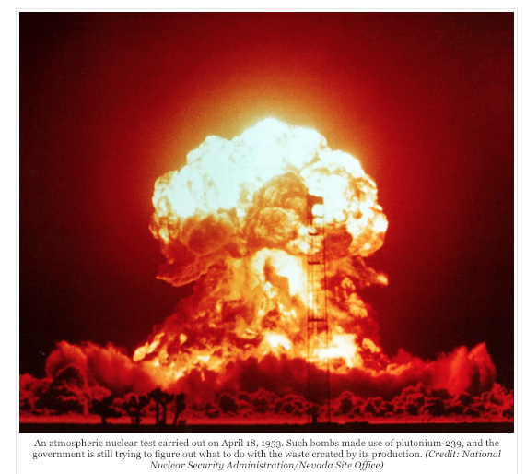
Nearly 30 years ago, the state of Washington and two federal agencies agreed to clean up the Hanford Nuclear Reservation, a 586-square-mile chunk of sagebrush desert where the U.S. produced plutonium for nuclear weapons starting 75 years ago. In the process, some 56 million gallons of concentrated, radioactive sludge and crystallized salts sit corroding within 177 steel-and-concrete underground tanks.

Although the tank waste is only a fraction of the total, its safe disposal is one of the site’s most urgent priorities. Eighteen years ago, workers began constructing a plant for “immobilizing” the remaining waste by vitrifying it — a process whereby it is mixed with molten glass, cooled and encased in stainless steel canisters for long-term storage underground in an as yet undesignated location.

Today the task remains unfinished.

How Did This Happen?
Construction of the world’s first plutonium production reactor began at the site in 1943. During World War II and throughout the Cold War, the U.S. made some 67 metric tons of plutonium at Hanford. Its reactors bombarded uranium-238 with neutrons to produce uranium -239. This undergoes further decays to produce plutonium-239, the isotope best suited to producing big controlled explosions like the Fat Man bomb that burst over Nagasaki in 1945.

Every bombardment produced a chain of fission products, each with its own half-life and decay chain. The extremely long half-life of some of these byproducts (tens of thousands of years) dictates that the waste must be contained for longer than most humans can imagine, let alone ensure its active management. But the problem is not just radiation: The waste’s chemistry, too, can make the problem appear insoluble.

Scary — But How Dangerous?
The thought of both radiation and toxic chemicals tends to make people uneasy. And according to David Clark, who studies plutonium (Pu-239, half-life 24,100 years) at Los Alamos National Laboratory, most people fear the element because of its association with nuclear weapons. However, if it’s not in a bomb or misbehaving at a nuclear power plant, it’s generally only harmful if a person ingests or inhales it. Two other, more concerning, fission products, cesium-137 (half-life about 30 years) and strontium-90 (half-life almost 29 years), will constitute the greatest amount of radioactivity in the Hanford waste for the next century. These two elements created so much heat in the tanks that much, but not all, of their mass has been removed to canisters kept cool underwater elsewhere at the site until the vitrification plant begins treating high-level waste. Currently that startup date is 2036.

Although the whole point of Hanford was to enrich plutonium for use elsewhere, there is still enough left in the waste, dense and insoluble, to make some experts nervous. It only takes about 10 kilograms to start a chain reaction. In 2012, most construction of the vitrification plant was suspended after the General Accountability Office released a highly critical report, and two years after the Defense Nuclear Safety Board expressed strong concern that enough plutonium might collect somewhere in the plant — in the giant melters where the waste is mixed with molten glass-forming minerals, in the million feet of piping, or elsewhere — to initiate a chain reaction.

Not Your Mother’s Nuclear Waste
Nuclear power plant waste is successfully vitrified in many countries — but in most, only one chemical separation process to create fuel is used, whereas Hanford employed three major processes and several variations. And in terms of vitrification, the influence of chemistry far outstrips that of radiation. “It’s all the other elements that cause the trouble — so much so that “textbook chemistry doesn’t work at Hanford,” said Hanford chemist Vince Panesco in remarks to a February 2018 National Academy of Sciences panel.

Whalen agrees. “You’ve got thousands of compounds and the chemistry is constantly changing,” she said. “They’ve already formed a lot of compounds that were never originally put in the tanks.”
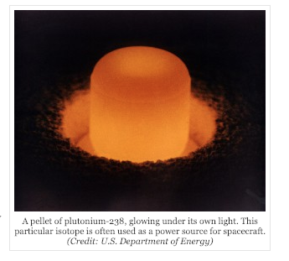

Radionuclides, We Hardly Know
In addition to the heavier elements, the regulators require technetium-99 (half-life 211,000 years) and iodine-129 (half-life 15.7 million years) to be controlled. Unlike the heavy metals, both of these are highly soluble and highly volatile, which means they can escape solids and liquids. During vitrification, the temperatures required to melt the glass will be high enough for them to depart the melt. They must be captured and returned to the waste stream at some point.

Technetium-99 has created a radiochemical mystery. According to Clark, chemists assumed that it would react with oxygen to form pertechnetate, which they knew they could remove with what are called ion exchange columns. That would solve the problem of technetium escaping. But that’s not what all the technetium did: A considerable percentage formed a still-unidentified compound that the ion exchange columns don’t capture.

(a) Explain what is meant by the process of “vitrifying” the radioactive materials?
(1 mark)
This is when the radioactive waste is mixed with molten glass, allowed to cool and solidify and then stored long term in stainless steel drums. ✔
(b) How is it possible to produce plutonium-239 from uranium-238?
(2 marks)
(c) Explain what the author means by “Every bombardment produced a chain of fission
The uranium-238 must first absorb the neutron as mentioned in the article. This will produce Ur-239, ✔ which must then undergo further decays to eventually produce Pu-239. ✔
(The actual series is: 1.Uranium-238 is struck with a high-energy neutron and is converted into Uranium-239 with the absorption of a neutron. 2. Uranium-239 is then changed into Neptunium-239 by the emission of an electron and an anti-neutrino particle through beta (β–) decay.
3. Neptunium-239 loses an electron and an anti-neutrino particle to form Plutonium-239)

products, each with its own half-life and decay chain”?
(4 marks)
(d) Why must the waste be contained for such a long period of time?
(1 mark)
(e) Suggest a reason why Pu-239 is “generally only harmful if a person ingests or inhales
The waste must be contained for a long period of time because the radioactive material present has such a long half life and the radiation produced when they decay are dangerous.
Each bombardment will produce a number of different radioisotopes which are unstable and will then go on to produce new radioistopes when they decay. Each of the radioisotopes has a particular and different half life and will go on to produce new radioistopes in a decay chain.✔✔✔✔
it”?
(2 marks)
Pu-239 is probably an alpha emitter. Alpha particle are can be easily stopped by the top bead layer of skin, thus they are unlikely to cause damage to the living cells. If ingested into the body, the alpha particle can have direct contact to living cells and thus can damage them. ✔✔
(f) Explain how an accidental chain reaction could theoretically occur in the plant?
(2 marks)
Since it only requires about 10kg of Pu-239 to start a chain reaction, it may be possible for this amount of Pu-239 to accidently collect in parts of the plant and thus initiate a chain reaction. ✔✔

(g) The author states that “They’ve already formed a lot of compounds that were never originally put in the tanks”. Explain how this is possible? (2 marks)
Nuclear transformations produce fission products that were not originally present and these products are able to thus form new compounds. ✔✔
(h) In the vitrification process, what were some of the issues concerning the vitrification of technetium-99 and iodine-129?
(2 marks)
Both of these are highly soluble and highly volatile, which means they can escape solids and liquids. During vitrification, the temperatures required to melt the glass will be high enough for them to be given off. They then must be collected and somehow returned to the waste. ✔✔
Question 19 HOUSEHOLD INSULATION (20 marks)
Heat is transferred from one place or object to another in three different ways: by conduction, by convection, and by radiation. This question deals with conduction.
When a metal poker is put in a hot fire, or a silver spoon is placed in a hot bowl of soup, the exposed end of the poker or spoon soon becomes hot as well, even though it is not directly in contact with the source of heat. We say that heat has been conducted from the hot end to the cold end.
Heat conduction in many materials can be visualized as being carried out via molecular collisions. As one end of an object is heated, the molecules there move faster and faster ( higher temperature). As these faster molecules collide with slower-moving neighbors, they transfer some of their kinetic energy to them, which in turn transfer some energy by collision with molecules still farther along the object. Thus the kinetic energy of thermal motion is transferred by molecular collision along the object. In metals, collisions of free electrons are mainly responsible for conduction. Conduction between objects in physical contact occurs similarly.
Heat conduction from one point to another takes place only if there is a difference in temperature between the two points. Indeed, it is found experimentally hat the rate of heat flow through a substance is proportional to the difference in temperature between its ends. The rate of heat flow also depends on the size and shape of the object. To investigate this quantitatively, let us consider the heat flow through a uniform cylinder, as illustrated below.
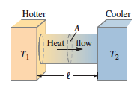

It is found experimentally that the heat flow Q over a time interval is given by the relation
$$\frac{Q}{t}=kA\frac{T_{1}-T_{2}}{l}$$
where A is the cross-sectional area of the object, $l$ is the distance between the two ends, which are at temperatures T₁ and T₂, and k is a proportionality constant called the thermal conductivity which is characteristic of the material.

(a) Explain the difference between “heat” and “temperature” ?
(2 marks)
(b) Using the equation above, determine the S.I. units for thermal conductivity.
(2 marks)
(c) Explain what is meant by saying that the thermal conductivity is “characteristic of the material”?
(1 mark)
(d) If k is large for a material, what would that indicate about how well it conducts thermal energy?
(1 mark)
$$\frac{J}{s}=km^{2}\frac{K}{m}$$

Thus k = Jm⁻¹K⁻¹s⁻¹ and since a Js⁻¹ is a Watt, unit is Wm⁻¹K⁻¹✔✔
Heat is a form of energy and is measured in Joules, ✔ whilst temperature is a measure of how hot or cold something is. ✔

This means that for a given substance, it does not matter about the quantity that you have, k is always constant and it depends only on the material. ✔

The thermal conductivity constant is larger for materials that transfer heat well (like metal and stone), and kk is small for materials that transfer heat poorly (like air and wood) ✔

Two students decided to conduct an experiment to determine the thermal conductivity of glass, typical to what you might find in the windows at home.

For this experiment, they used panes of glass 20.0 cm high and 15.0 cm wide and of varying thickness. The inside of each glass pane was kept at a constant temperature of 40.0ºC and the outside of each glass pane at a constant 26.0ºC. A joulemeter was used to measure the thermal energy transferred in each one minute run of the experiment.
The results of the experiment are shown below.

Thickness of glass, l,  x 10⁻³  (m) | Thermal energy transferred, Q,  (J) | Thermal energy transferred per second, Q/t  ( W ) ✔ | 1/l  ( m⁻¹) ✔
1.0 | 211.7 | 3.5 | 1000.0
2.0 | 105.8 | 1.8 | 500.0
3.0 | 70.6 | 1.2 | 333.3
4.0 | 52.9 | 0.9 | 250.0
5.0 | 42.3 | 0.7 | 200.0
6.0 | 35.3 | 0.6 | 166.7
7.0 | 30.2 | 0.5 | 142.9
8.0 | 26.5 | 0.4 | 125.0
9.0 | 23.5 | 0.4 | 111.1
10.0 | 21.2 | 0.4 | 100.0

(e) What could have been done in order to increase the reliability of the results?
(1 mark)
(f) For this experiment: (3 marks)
Increase the number of trials ✔

(i) What was the dependent variable?
(ii) What was the independent variable?
The thickness of the glass ✔
The thermal energy transferred ✔
(iii) What were some variables that were/should have been controlled?
Height and width of the glass
Glass type
Temperature differential
Humidity
How the Joulemeter was used
Time (one minute)
etc
✔

(g) Complete the two incomplete columns in the table and include units. (2 marks)

(h) On the following graph paper, draw a graph that shows the relationship between Q/t on the vertical axis and 1/l on the horizontal axis. (4 marks)

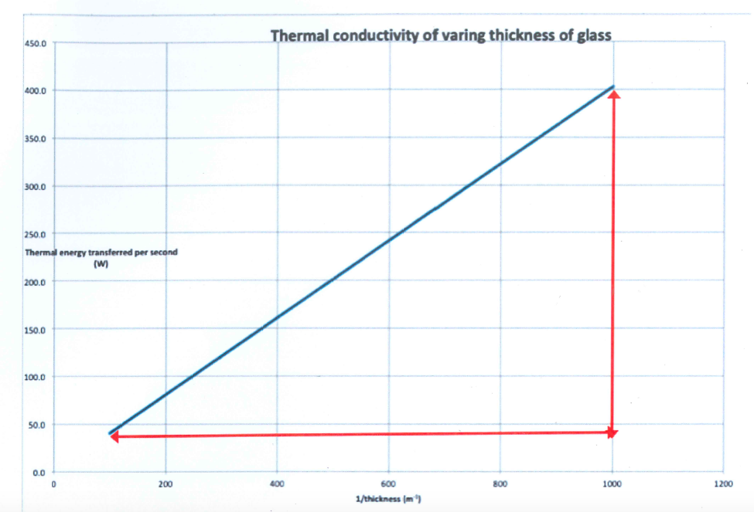
Correct data points✔
Line of best fit✔
Labels on each axis✔
Units on each axis✔
(i) Determine the gradient of the line of best fit including units. Be sure to show how you calculated the gradient.
(2 marks)
Gradient = rise/run
= (400-40) / (1000-100)
= 0.4 Wm ✔✔
Units on each axis✔
(j) From the gradient calculated in (g), determine the thermal conductivity of the glass.
(2 marks)
Since $$\frac{Q}{t}=kA\frac{T_{1}-T_{2}}{l}$$then a graph of Q/t v 1/l should yield a straight line with gradient being kAΔT✔
Thus 0.40 = k (0.20 x 0.15) x (40-26). Thus k = 0.95 Wm⁻²✔

END OF SECTION THREE

Extra Space

___________________________________________________________________________________
___________________________________________________________________________________

___________________________________________________________________________________
___________________________________________________________________________________

___________________________________________________________________________________

___________________________________________________________________________________

___________________________________________________________________________________

___________________________________________________________________________________

___________________________________________________________________________________

___________________________________________________________________________________

___________________________________________________________________________________

___________________________________________________________________________________

___________________________________________________________________________________

___________________________________________________________________________________

___________________________________________________________________________________

___________________________________________________________________________________

___________________________________________________________________________________

___________________________________________________________________________________

___________________________________________________________________________________

___________________________________________________________________________________

___________________________________________________________________________________

___________________________________________________________________________________

___________________________________________________________________________________

___________________________________________________________________________________

___________________________________________________________________________________

___________________________________________________________________________________

___________________________________________________________________________________

___________________________________________________________________________________
Extra Graph for question 12

Extra Graph for question 18

Acknowledgements

Question 7

Brain, M. and Elliott, S. (2019). How Refrigerators Work. [online] HowStuffWorks. Available at: https://home.howstuffworks.com/refrigerator.htm [Accessed 1 Feb. 2019].

Question 19

Brain, M. (2019). How Smoke Detectors Work. [online] HowStuffWorks. Available at: https://home.howstuffworks.com/home-improvement/household-safety/smoke.htm [Accessed 12 Jan. 2019].

WATP acknowledges the permission of School Curriculum and Assessment Authority in
providing instructions to students.

